

CSA0501-DATABASE MANAGEMENT SYSTEMS

LAB EXPERIMENTS DATE: 29/07/2026

EXPERIMENT 19–TRIGGER

AIM:
To implement triggers in MySQL using the milka_dairy table to automatically record changes made to the table.
procedure:
- Create the milka_dairy table with the fields name, liters, amount, account_number, phone_number, and bank_name.
- Create a new table named milka_dairy_audit to store the details of the changes made to the milka_dairy table.
- Use the CREATE TRIGGER statement to create a trigger.
- Specify the trigger name as before_milka_update.
- Specify BEFORE UPDATE so that the trigger executes before a record is updated.
- Use FOR EACH ROW so that the trigger executes for every updated record.
- Use OLD to access the existing values before the update.
- Use NEW to access the new values that are going to be stored.
- Insert the old and new values into the milka_dairy_audit table.
- Update a record in the milka_dairy table to test the trigger.
- Use the SELECT statement to display the audit records.

Problem-1

Create a trigger in MySQL to log the changes made to the milka_dairy table. Create a new table named MILKA_DAIRY_AUDIT to store the old and new values when a customer's details are updated. Create a BEFORE UPDATE trigger that is invoked before a change is made to the milka_dairy table.

Create Audit Table
CREATE TABLE milka_dairy_audit (
audit_id INT AUTO_INCREMENT PRIMARY KEY,
customer_name VARCHAR(20),
old_liters INT,
new_liters INT,
old_amount INT,
new_amount INT,
old_bank_name VARCHAR(20),
new_bank_name VARCHAR(20)
);

Create Trigger
DELIMITER //

CREATE TRIGGER before_milka_update
BEFORE UPDATE ON milka_dairy
FOR EACH ROW
BEGIN
INSERT INTO milka_dairy_audit
(
customer_name,
old_liters,
new_liters,
old_amount,
new_amount,
old_bank_name,
new_bank_name
)
VALUES
(
OLD.name,
OLD.liters,
NEW.liters,
OLD.amount,
NEW.amount,
OLD.bank_name,
NEW.bank_name
);
END //

Test the Trigger
For example, update Kamala's milk details:
UPDATE milka_dairy
SET liters = 16,
amount = 1600
WHERE name = 'Kamala';
SELECT * FROM milka_dairy_audit;

OUTPUT:
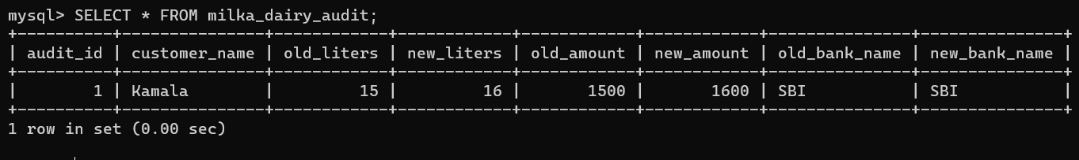

RESULT:
Thus, the BEFORE UPDATE trigger was created and executed successfully to record changes made to the milka_dairy table.

